Final Project Report

* Business Application Overview

Our application is used for an ecommerce site, Amazon. The application supports the entire business process: suppliers provide all kinds of product options; Amazon sort and distribute products online; customers choose and make orders; delivery agencies end the process by deliver customer orders. Thus, we include Supplier, Amazon, Customer, and Delivery Agent as main users in this business application. Besides discovering the business process, we streamlined data management process by designing Data Models and using database management system. With that, Amazon can easily find some underlying business information they want to track and analysis, also help them to solve some complex problems.

* User Types
  + Supplier: Distribute products to Amazon warehouse.
  + Amazon: Ecommerce company that sort products and sell them to customers through internet.
  + Customer: People who purchase products through Amazon.
  + Delivery agent: Logistics professionals who deliver the products to End Users.
* Use Cases
  + Amazon
    - Amazon would like to obtain how many products each customer order per month through customer_id and order_id.
    - Amazon would like to find availability of a certain product by checking supplier inventory.
    - Amazon would like to know their annual sales each year based on products price and quantity sold.
    - Amazon would like to find out the most popular products by month/year through order_id and product_id.
  + Customer
* Customers would like to know what products they ordered before by using order_id and product_id.
* Customers would like to track the shipment information through tracking number.
  + Supplier
    - Supplier like to know how many inventories and what type of inventories amazon sell per month/year through order quantity or order_id.
    - Supplier would like to find out their monthly sales performance.
  + Delivery agent
* Delivery agent would like to know how many products were shipped out by them each month through order_id or quantity.
* Delivery agent would like to find out how many order was successfully delivered within 2 days through shipping_date and delivering_date.
* What’s the average time for a order to be delivered by checking delivery date and shipping date.
* Swim Lane Diagram
* 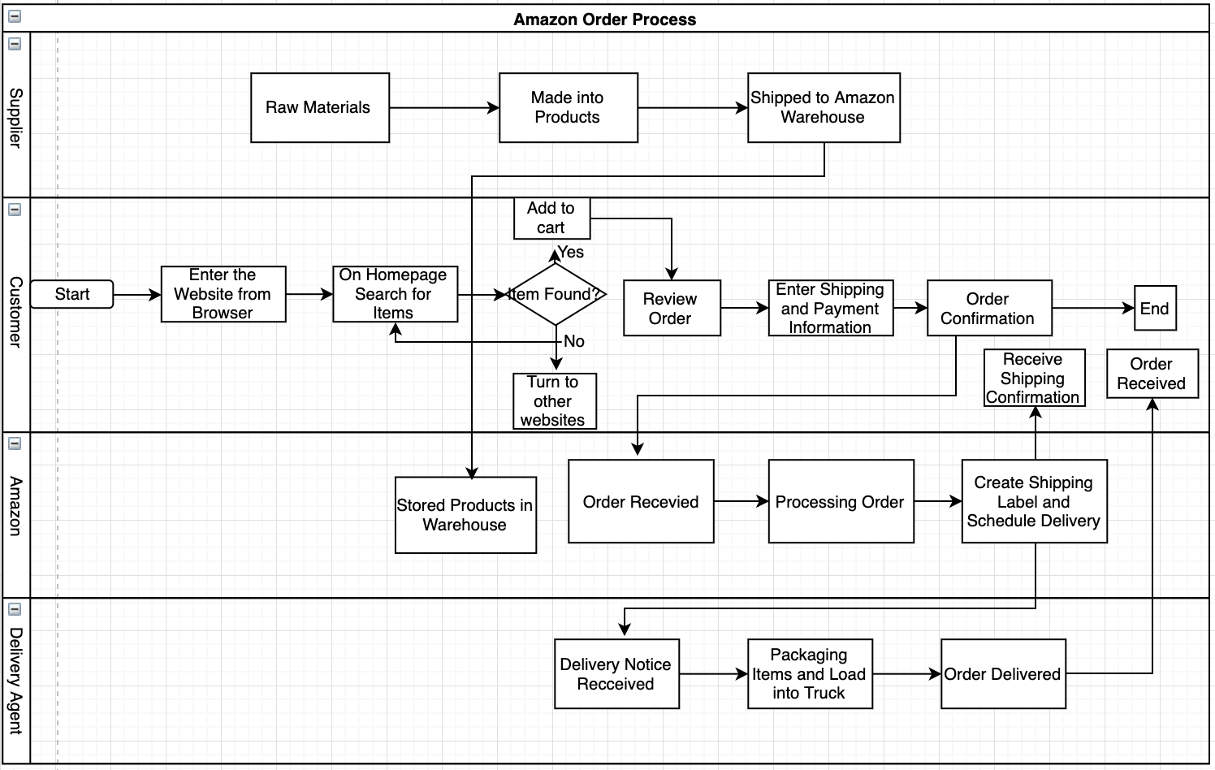
* ERD

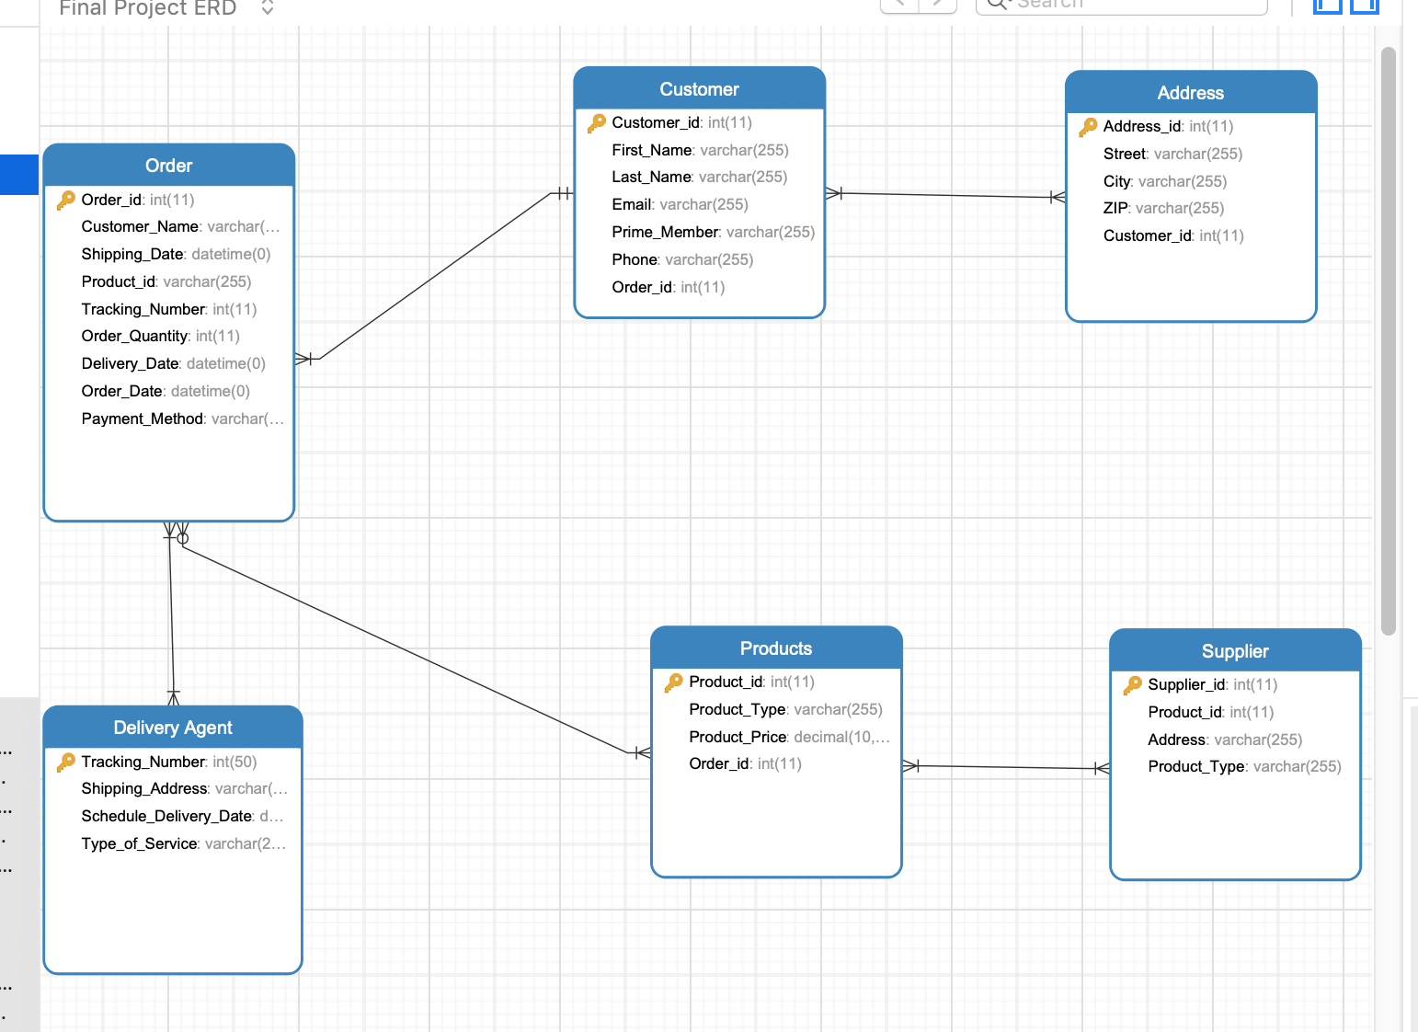

**Business Metrics**

1. Popularity of different product types

* Home & Kitchen , Office Supply (3 orders per type)
* Books & Audio, Food, Health & Lifestyle (2 orders per type)
* Beauty, Sports & Outdoors (1 order per type)
* 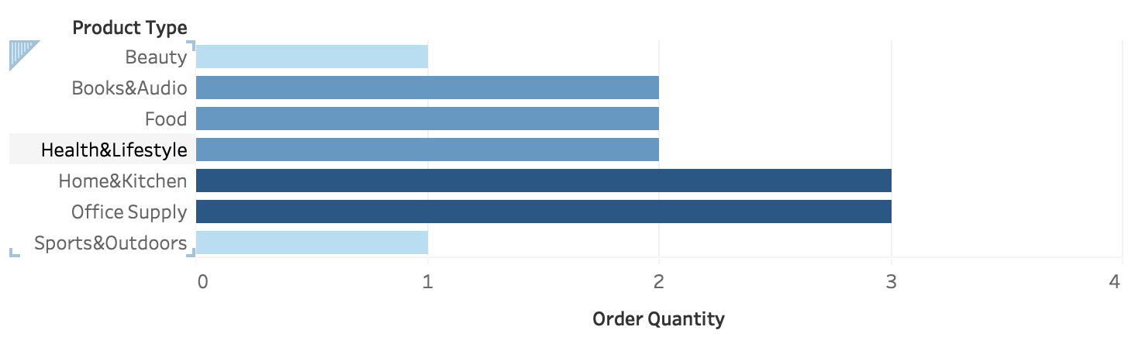

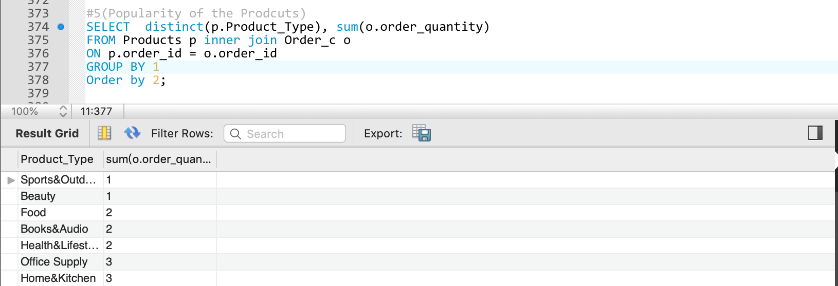

2. Customer Distribution by State

* Targeting Marketing Efforts
* Supply Chain and Supplier
* 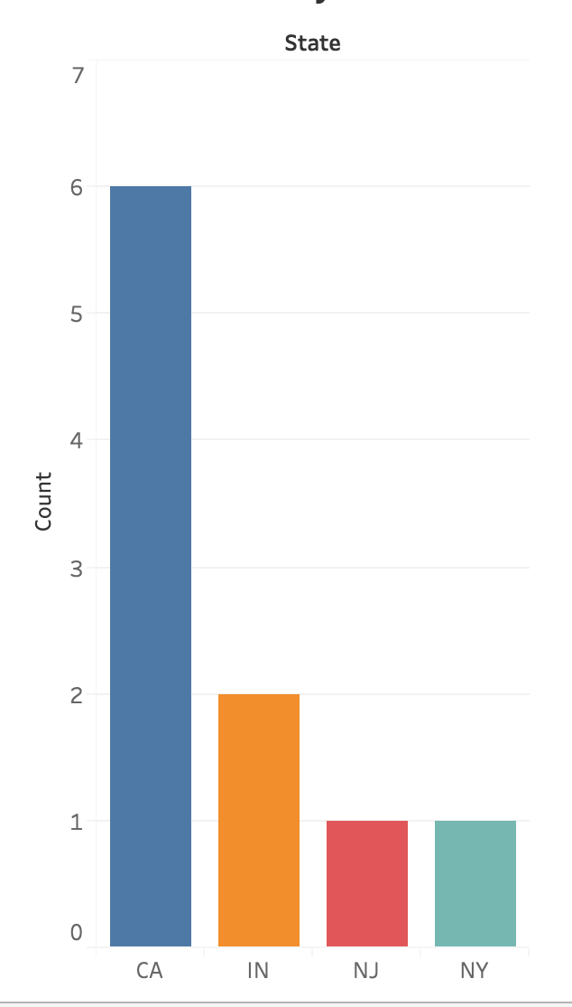

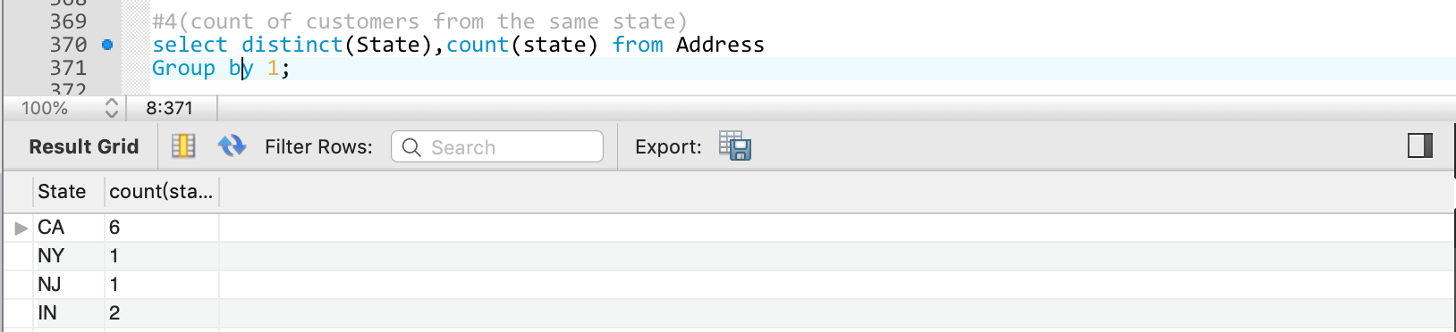

3. Average Days of Delivery (By Product)

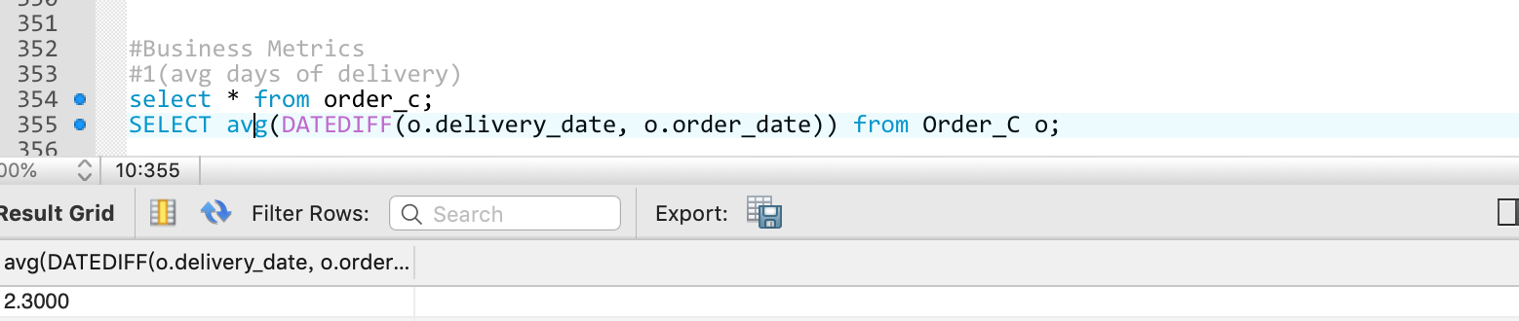

4. Prime Members & Choose 2-Day Delivery

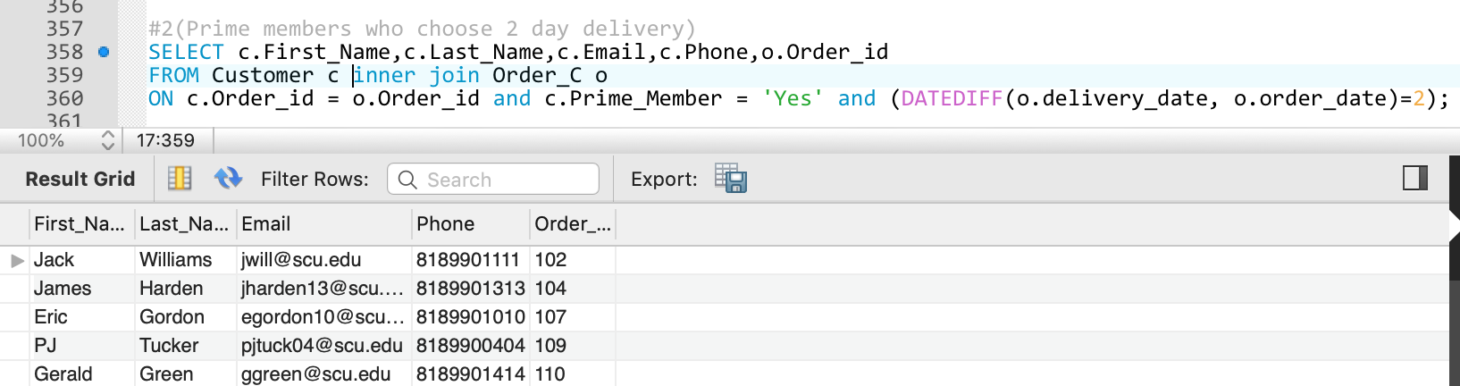

5. Distribution of Delivery Time

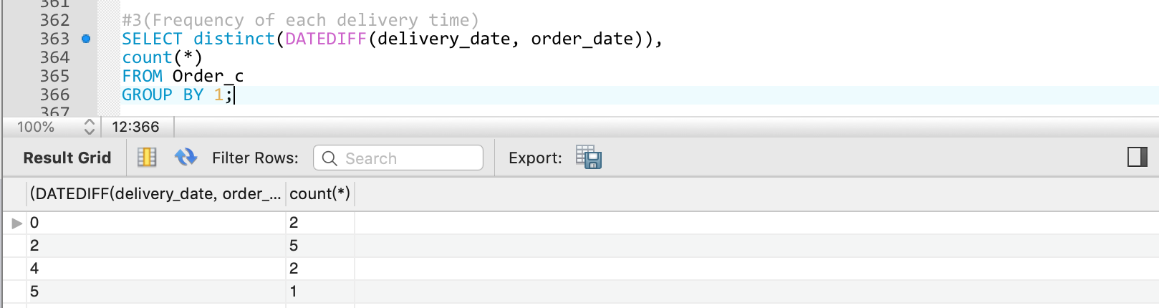

**Project Summary**

Overall, we had a good experience with this exercise. We learned how to build a database system from scratch to build actual physical schema. By creating the swim lane diagram and entity relationship diagram, we realized the steps it take to build a strong eCommerce business from importing inventories from suppliers to final delivery to customers. Finally, after inserting, updating, and deleting data from our data table we find some interesting business metrics that could eventually lead to better business solutions for the company.

Through this project, we’ve learned substantial knowledge regarding business analytics and data modeling. However, we also encountered some difficulties along the process. For example, when creating relations between entities, we need to set foreign keys in reference to primary keys. Also, in order to transfer data to useful business insights and better convey our analysis to non-technical audience, we learned to use visualization tools such as Tableau. If we were to do this project again, the methodology we would follow is to build the data model on clearly defined user types and use cases.